Table of content

BRAKE SYSTEM 3

SPECIFICATIONS: 3

CHOICE OF COMPONENTS: 5

PROBLEMS FACED WITH THE SYSTEM: 5

MODIFICATIONS 5

ROTOR SIZING 6

DESIGN OBJECTIVE 6

METHOD 6

VALIDATION 9

FUTUR IMPROVEMENTS: 9

BRAKE COMPONENTS SIZING 11

DESIGN OBJECTIVES 11

METHOD 11

DESIGN TABLES 11

BRAKE SETUP OPTIMISATION 14

CONTROLS 17

SPECIFICATIONS 17

CHOICE OF COMPONENTS 18

STEERING SYSTEM 19

DESIGN OBJECTIVES 19

METHOD 19

VALIDATION 19

SHIFTER SYSTEM 23

COMPONENTS 23

DESIGN OBJECTIVE 23

VALIDATION 23

PEDAL BOX 24

Design objectives 24

METHOD 24

DRIVER’S POSITION / ERGONOMICS / SAFETY 26

SPECIFICATIONS 26

Design 26

BRAKE SYSTEM

**SPECIFICATIONS**:

Calipers:

* Front : ISR 248-0B, 4 piston, 25mm dia, machined from billet aluminium, fixed

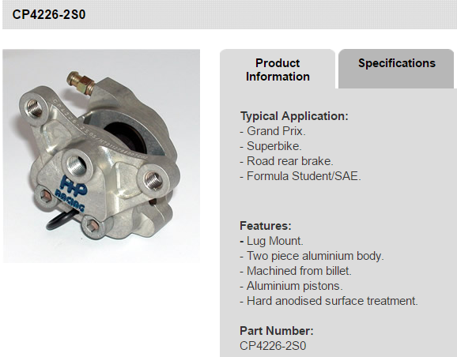

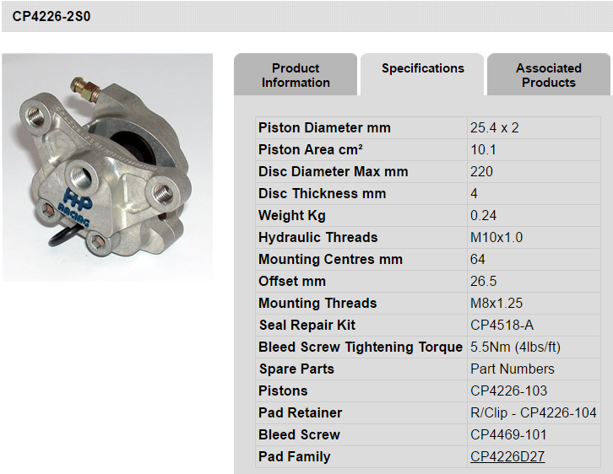

* + Pads: ISR 29-002, SBS-S-DC10-HH
* Rear: AP Racing CP4226-2S0, Two piston, 25.4 mm dia.,machined from billet aluminium, fixed

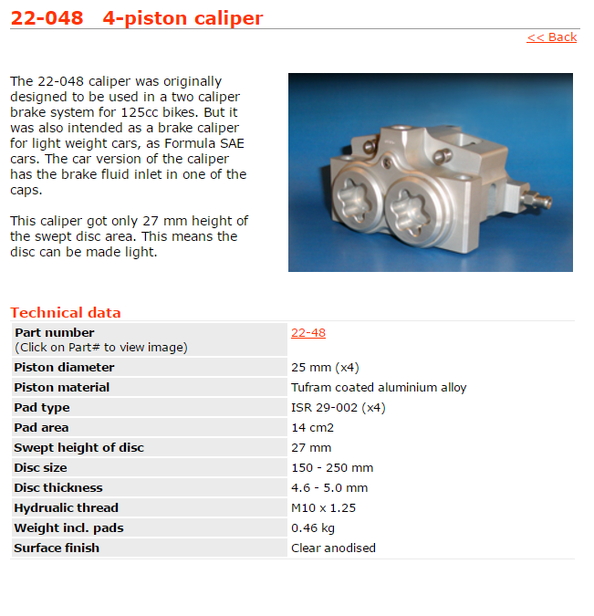

* + AP Racing CP4226D27, APH420 material

Master Cylinder: two independent systems front/rear

* Front: Tilton engineering series 77, 0.75" bore , adjustable balance bar
* Rear: Tilton engineering series 77, 0.70" bore and proportioning valve

Rotors:

* Front: Floating mild steel, hub mounted 200mm dia, 4.7 mm thick, laser cut
* Rear: Floating mild steel, hub mounted 200mm dia, 3 mm thick, laser cut

Oil:

* Dot 4

Brake lines: hard line aluminum, rated 3200 psi, 6061T6 vs braided hose we save 2.24lbs + 1.33 lbs of fittings

**CHOICE OF COMPONENTS:**

Sought after general characteristics:

1. Price
2. Accessibility of spare parts
3. reliability

Calipers: Diameter, number of pistons, weight impact, packaging, effective radius, weight

*Options considered*: AP for Front, Willwood, Brembo, akebono

Pads: Availability, information given on lining material, capability with rotor

Master Cylinder: Achieve certain pressure, light weight, spherical end

Advantages:

* Experience with components
* The team has many spare parts

**PROBLEMS FACED WITH THE SYSTEM:**

* Building pressure in the system (2016)
* Difficulties getting high in temperatures (2016)

**MODIFICATIONS**

* Balance bar
* Proportioning valve

ROTOR SIZING

DESIGN OBJECTIVE

* Reduce weight
* Reach optimum temperature for pads

METHOD

* Iterations
* Lump capacitance method (temperature is considered equal in all rotor)

|  |  |  |  |
| --- | --- | --- | --- |
| Speed: | 16 | m/s |  |
| Diameter: | 0.2 | m |  |
| Nu : | 1.89E-05 |  |  |
| Ka : | 0.0285 |  |  |
| Re : | 1.69E+05 | - |  |
| h_r : | 74.936 | W/m^2 * K |  |
| Ar : | 0.02 | 0.019 | m^2 |
| Tr : | 0.0048 | 0.0032 |  |
| Rho_r : | 7226 | kg/m^3 |  |
| rotor volume : | 0.000096 | 0.0000608 | m^3 |
| Mass : | 272.72 | kg |  |
| Decel : | 7.829 | g |  |
| To : | 7 | ⁰C |  |

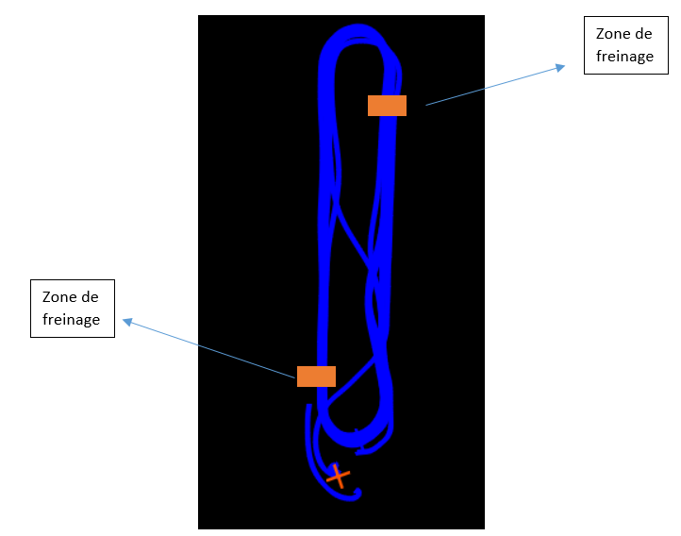

|  |  |  |  |  |
| --- | --- | --- | --- | --- |
| Brake applications | |  |  |  |
|  | T |  | a | b |
| 1 | 30.0364802 |  | 0.07747844 | 0.07747844 |
| 2 | 51.2881297 |  | 0.14895397 | 0.07747844 |
| 3 | 70.8932347 |  | 0.21489169 | 0.07747844 |
| 4 | 88.9793666 |  | 0.27572066 | 0.07747844 |
| 5 | 105.664213 |  | 0.33183669 | 0.07747844 |
| 6 | 121.056344 |  | 0.38360495 | 0.07747844 |
| 7 | 135.255916 |  | 0.43136227 | 0.07747844 |
| 8 | 148.355328 |  | 0.47541944 | 0.07747844 |
| 9 | 160.439818 |  | 0.51606312 | 0.07747844 |
| 10 | 171.58802 |  | 0.5535578 | 0.07747844 |

Front Rotor Temps:

Rear Rotor Temps:

|  |  |  |  |  |
| --- | --- | --- | --- | --- |
| Brake applications | |  |  |  |
|  | T |  | a | b |
| 1 | 22.5885956 |  | 0.11393662 | 0.11393662 |
| 2 | 36.4010792 |  | 0.21489169 | 0.11393662 |
| 3 | 48.6398152 |  | 0.30434428 | 0.11393662 |
| 4 | 59.4841108 |  | 0.38360495 | 0.11393662 |
| 5 | 69.0928441 |  | 0.45383492 | 0.11393662 |
| 6 | 77.6067907 |  | 0.51606312 | 0.11393662 |
| 7 | 85.150687 |  | 0.57120126 | 0.11393662 |
| 8 | 91.8350572 |  | 0.62005714 | 0.11393662 |
| 9 | 97.7578328 |  | 0.66334654 | 0.11393662 |
| 10 | 103.005787 |  | 0.7017037 | 0.11393662 |

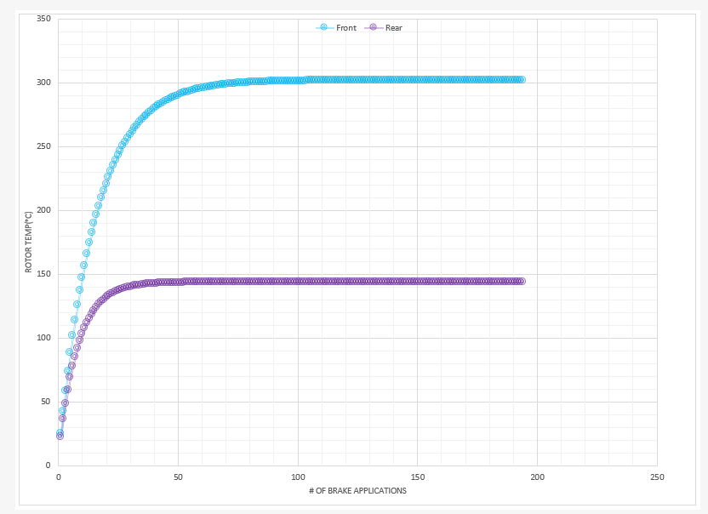

Hypothetic

VALIDATION

Thermocouples TYPE K were attached to pads to see if the temperature simulation was indeed true

Driver had to make 25 laps and brake 2 times each lap to recreate conditions in the hypothetic approach

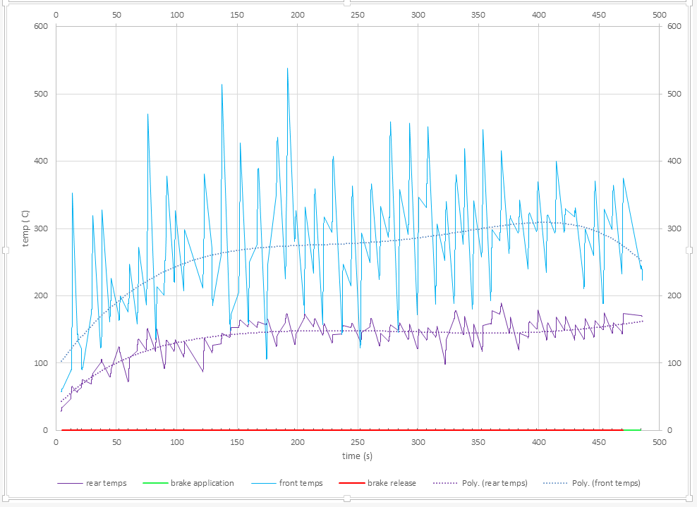

Experimental test

FUTUR IMPROVEMENTS:

There is a lot of noise in front temps signal, maybe use a different way to attach the thermocouples.

Projected temperature of Michigan 2016 endurance

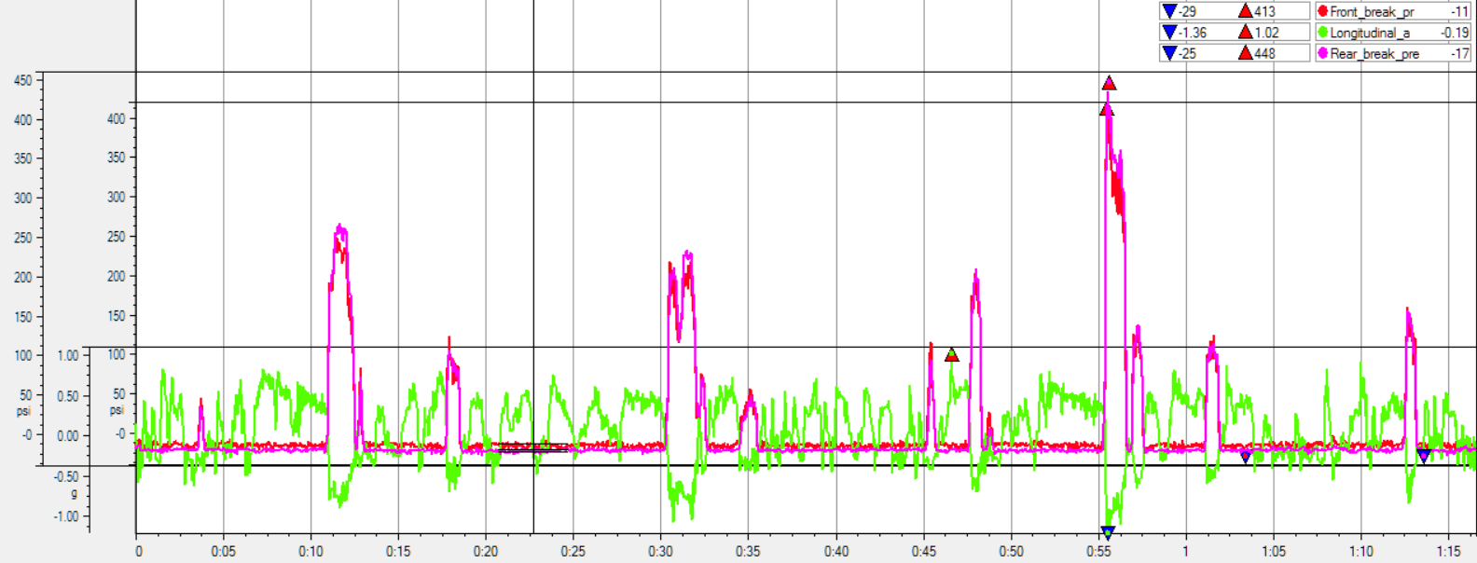

|  |  |
| --- | --- |
| Brake mean time | 0.467 seconds |
| Cooling mean time | 7.34 seconds |

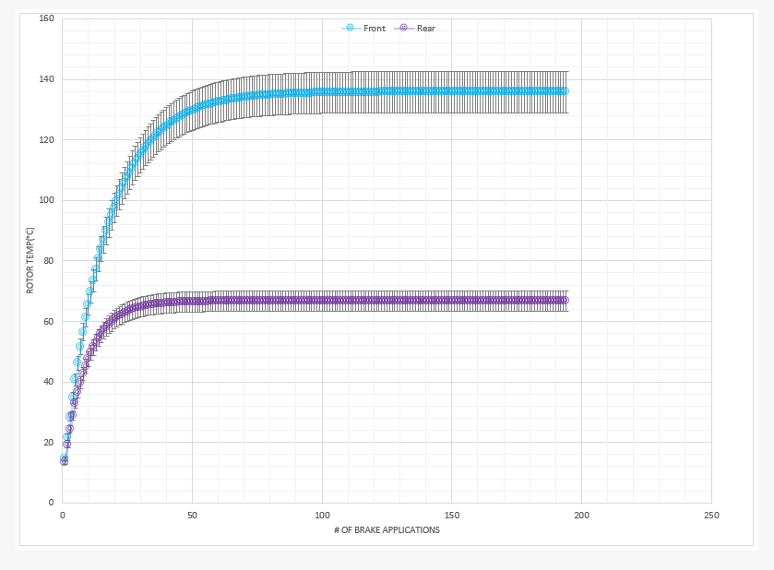

Stagnation temperature of rotors Michigan endurance 2016

BRAKE COMPONENTS SIZING

DESIGN OBJECTIVES

* reliable
* no possible failures

METHOD

With loads previously obtained, it is essential to respect maximum ratings of standard (non-designed) components such as hydraulic hoses, master cylinders and calipers (if applicable). A spreadsheet has been made in order to assure constant respect of these limitations during all stages of braking.

* 270 N/g of deceleration
* Force to lock up 375 N
* Variable pedal ratio
* Bias 0.5
* Setup was selected to outcome the small friction coefficient of pads in the rear

|  |  |  |  |  |  |  |  |  |  |  |  |
| --- | --- | --- | --- | --- | --- | --- | --- | --- | --- | --- | --- |
| **Master Cylinder sizes** | |  | **Pedal ratios** |  | Force applied to pedal | | |  | **Front/rear bias** | | 0.5 |
| In | mm |  | - |  |  | lbf | N |  | **Max caliper rating (PSI)** | | 1500 |
| 0.625 | 15.875 |  | 2 |  | min | 70 | 311.3755134 |  |  |  |  |
| 0.75 | 19.05 |  | 2.5 |  | max | 449.6189 | 2000 |  |  |  |  |
| 0.8125 | 20.6375 |  | 3 |  |  |  |  |  |  |  |  |
| 0.875 | 22.225 |  | 3.5 |  |  |  |  |  |  |  |  |
| 1 | 25.4 |  | 4 |  |  |  |  |  |  |  |  |
| 1.125 | 28.575 |  | 5 |  |  |  |  |  |  |  |  |

DESIGN TABLES

|  |  |  |  |  |  |  |
| --- | --- | --- | --- | --- | --- | --- |
|  | **Resulting min line pressure REAR (psi)** | | | | | |
| **mc size/pedal ratio** | **2** | **2.5** | **3** | **3.5** | **4** | **5** |
| **15.875** | 228 | 285 | 342 | 399 | 456 | 570 |
| **19.05** | 158 | 198 | 238 | 277 | 317 | 396 |
| **20.6375** | 135 | 169 | 203 | 236 | 270 | 338 |
| **22.225** | 116 | 146 | 175 | 204 | 233 | 291 |
| **25.4** | 89 | 111 | 134 | 156 | 178 | 223 |
| **28.575** | 70 | 88 | 106 | 123 | 141 | 176 |
|  |  |  |  |  |  |  |
|  | **Resulting min line pressure FRONT (psi)** | | | | | |
| **mc size/pedal ratio** | **2** | **2.5** | **3** | **3.5** | **4** | **5** |
| **15.875** | 228 | 285 | 342 | 399 | 456 | 570 |
| **19.05** | 158 | 198 | 238 | 277 | 317 | 396 |
| **20.6375** | 135 | 169 | 203 | 236 | 270 | 338 |
| **22.225** | 116 | 146 | 175 | 204 | 233 | 291 |
| **25.4** | 89 | 111 | 134 | 156 | 178 | 223 |
| **28.575** | 70 | 88 | 106 | 123 | 141 | 176 |

|  |  |  |  |  |  |  |
| --- | --- | --- | --- | --- | --- | --- |
|  | **Resulting max line pressure REAR (psi)** | | | | | |
| **mc size/pedal ratio** | **2** | **2.5** | **3** | **3.5** | **4** | **5** |
| **15.875** | 1466 | 1832 | 2198 | 2565 | 2931 | 3664 |
| **19.05** | 1018 | 1272 | 1527 | 1781 | 2035 | 2544 |
| **20.6375** | 867 | 1084 | 1301 | 1518 | 1734 | 2168 |
| **22.225** | 748 | 935 | 1122 | 1309 | 1495 | 1869 |
| **25.4** | 572 | 716 | 859 | 1002 | 1145 | 1431 |
| **28.575** | 452 | 565 | 678 | 792 | 905 | 1131 |
|  |  |  |  |  |  |  |
|  | **Resulting max line pressure FRONT (psi)** | | | | | |
| **mc size/pedal ratio** | **2** | **2.5** | **3** | **3.5** | **4** | **5** |
| **15.875** | 1466 | 1832 | 2198 | 2565 | 2931 | 3664 |
| **19.05** | 1018 | 1272 | 1527 | 1781 | 2035 | 2544 |
| **20.6375** | 867 | 1084 | 1301 | 1518 | 1734 | 2168 |
| **22.225** | 748 | 935 | 1122 | 1309 | 1495 | 1869 |
| **25.4** | 572 | 716 | 859 | 1002 | 1145 | 1431 |
| **28.575** | 452 | 565 | 678 | 792 | 905 | 1131 |

**Pressure needed to lock up the wheels**

|  |  |  |  |  |  |  |  |
| --- | --- | --- | --- | --- | --- | --- | --- |
|  | piston dia(mm)/disc radius(m) | | **0.0889** | **0.09144** | **0.09398** | **0.09652** | **0.09906** |
| needed front pressure (Pa) | | **20** | 5508521.003 | 5355506.531 | 5210763.111 | 5073637.766 | 4943544.49 |
|  |  | **21** | 4996390.933 | 4857602.296 | 4726315.747 | 4601939.017 | 4483940.581 |
|  |  | **22** | 4552496.697 | 4426038.455 | 4306415.795 | 4193089.063 | 4085573.959 |
|  |  | **23** | 4165233.273 | 4049532.349 | 3940085.528 | 3836399.067 | 3738029.86 |
|  |  | **24** | 3825361.808 | 3719101.758 | 3618585.494 | 3523359.56 | 3433017.007 |
|  |  | **25** | 3525453.442 | 3427524.18 | 3334888.391 | 3247128.17 | 3163868.474 |
|  |  | **26** | 3259479.884 | 3168938.776 | 3083291.782 | 3002152.524 | 2925174.255 |
|  |  |  |  |  |  |  |  |
|  | piston dia(mm)/disc radius(m) | | **0.0889** | **0.09144** | **0.09398** | **0.09652** | **0.09906** |
| needed rear pressure (Pa) | | **20** | 4406816.803 | 4284405.225 | 4168610.489 | 4058910.213 | 3954835.592 |
|  |  | **21** | 3997112.746 | 3886081.837 | 3781052.598 | 3681551.214 | 3587152.465 |
|  |  | **22** | 3641997.358 | 3540830.764 | 3445132.636 | 3354471.25 | 3268459.167 |
|  |  | **23** | 3332186.618 | 3239625.879 | 3152068.423 | 3069119.254 | 2990423.888 |
|  |  | **24** | 3060289.446 | 2975281.406 | 2894868.395 | 2818687.648 | 2746413.606 |
|  |  | **25** | 2820362.754 | 2742019.344 | 2667910.713 | 2597702.536 | 2531094.779 |
|  |  | **26** | 2607583.907 | 2535151.021 | 2466633.425 | 2401722.02 | 2340139.404 |

BRAKE SETUP OPTIMISATION

* A math lab script was made to find optimum bias

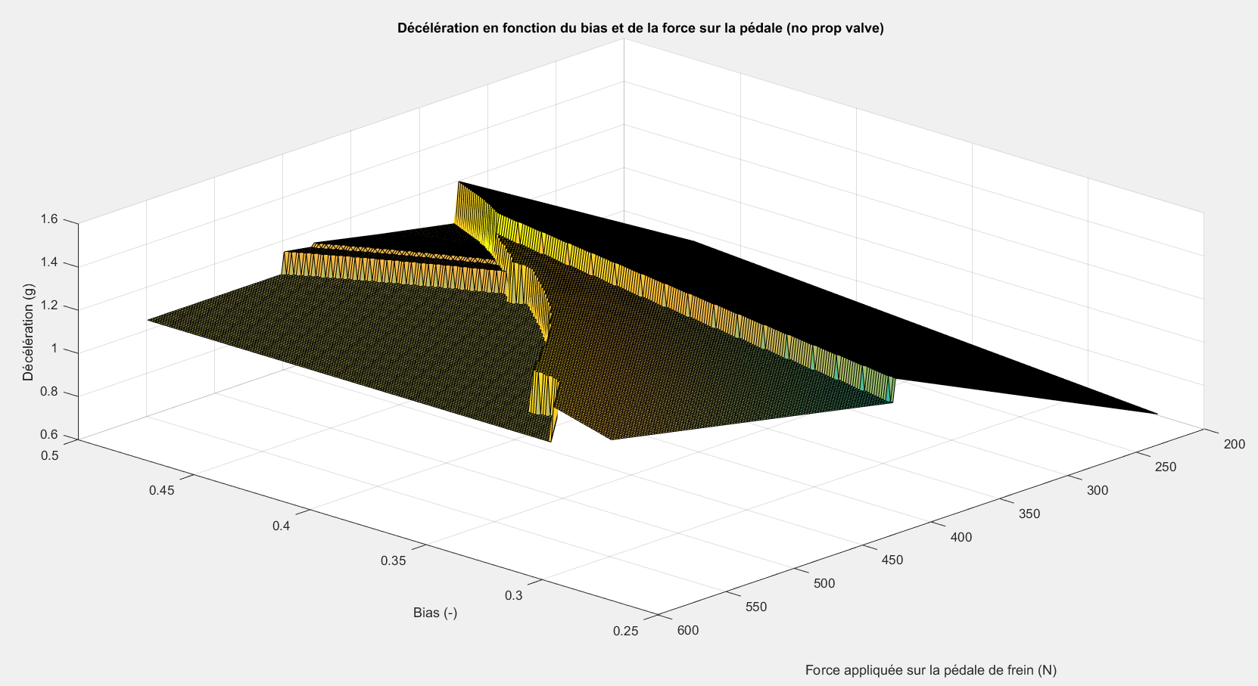

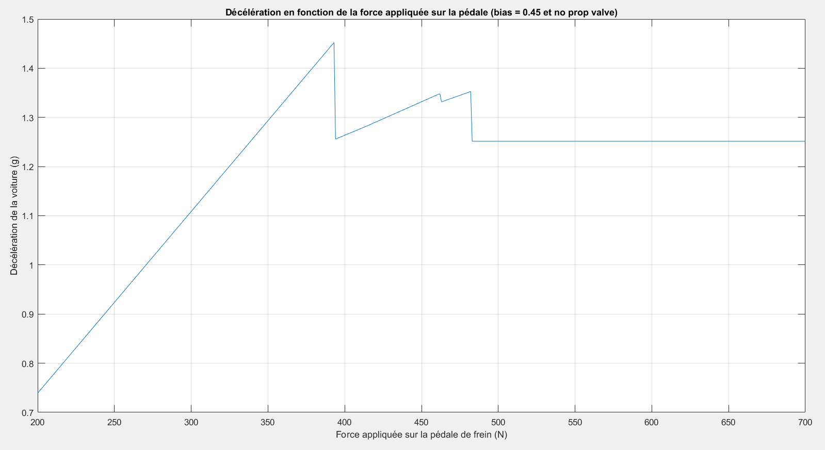

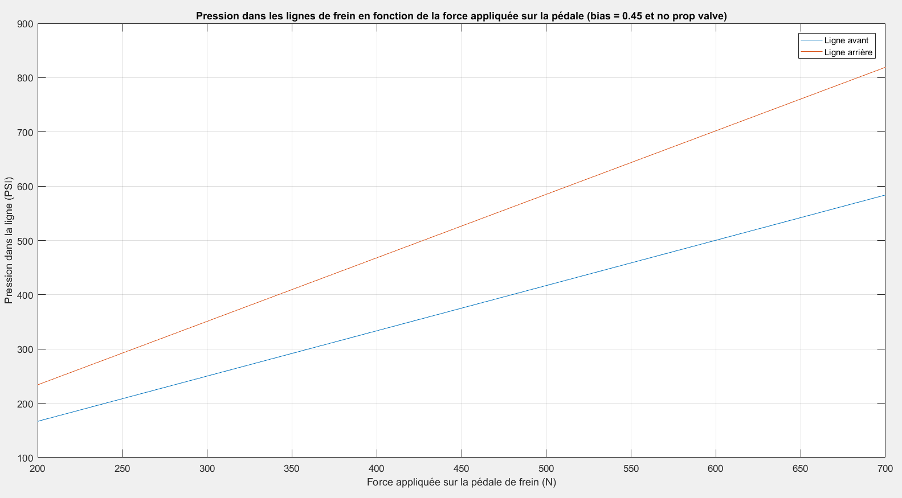

CONTROLS

SPECIFICATIONS

Steering wheel: momo mod.12, 250mm, spa quick connect

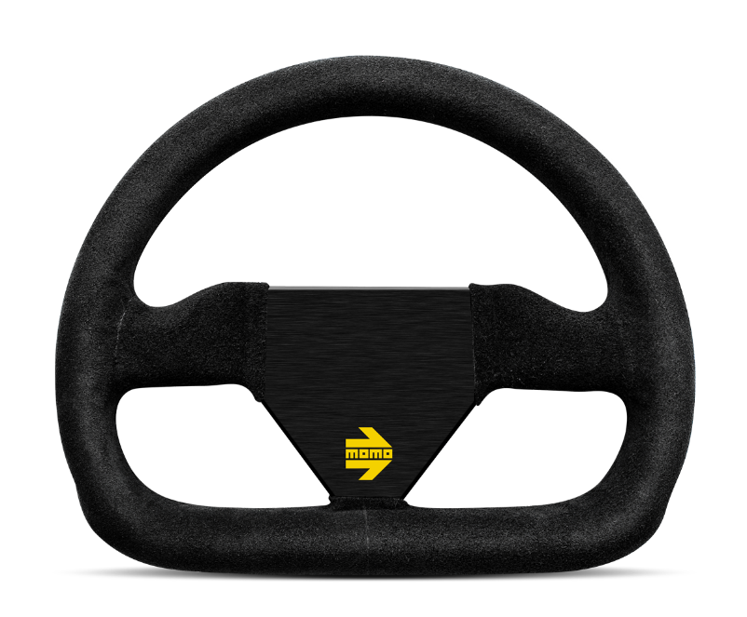

Steering rack: kaz technologies FSAE steering rack 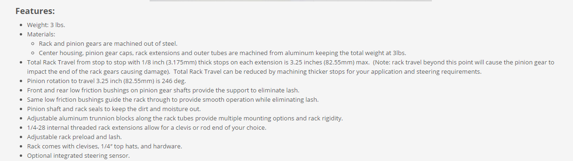

Steering column: double u-joint system

Clutch lever: stock brp ds450 clutch lever, by wire, launch control possibilities, adjustable position and motion ratio, off the shelf easy and fast to have

Shifter: Electro-pneumatic system, HPA

Throttle pedal: machined 6061T6 aluminum, cam pivot, hidden components, inverted, adjustable cups, by wire, adjustable sensitivity and travel

Brake pedal: machined 6061T6 aluminum, hidden components, inverted, adjustable cups

CHOICE OF COMPONENTS

Sought after general characteristics:

1. Price
2. Accessibility of spare parts
3. reliability

Steering wheel: Quality, comfortable, acceptable size, no worries about failures

Quick release: **SPA Steering Wheel Quick Releases conform to the latest FIA technical specification, no worries about failures**

**Steering column: Minimising compliance in the system for optimal feedback for drivers, good steering effort**

**Steering rack: adjustable pre-load and lash, travel, durability, adjustable setup, weight price ratio**

**Shifter: Stability and feedback, weight, simplicity**

**Throttle pedal: rigid, good feedback, adjustable**

**Brake pedal: rigid, minimal compliance, good feedback, comfortable**

STEERING SYSTEM

DESIGN OBJECTIVES

* Reduce weight
* Have more turning radius → one turn at Lincoln 2016 was barely enough
* Good feedback

METHOD

* We don’t use the rack full travel, we are using bushing that minimize the travel.
* New clevis were made to simplify and have less different spacers and bushing on the car, bushings are now same as the suspension.

VALIDATION

Steering angle characterisation

|  |  |
| --- | --- |
| wheel angle | steering angle |
| -24.2 | -104 |
| -20 | -83 |
| -16 | -66 |
| -12 | -51 |
| -8 | -33 |
| -4 | -18 |
| 0 | -2 |
| 4 | 13 |
| 8 | 30 |
| 12 | 46 |
| 16 | 62 |
| 20 | 79 |
| 23.5 | 99 |
|  |  |

Michigan 2016 wheel angles analysis

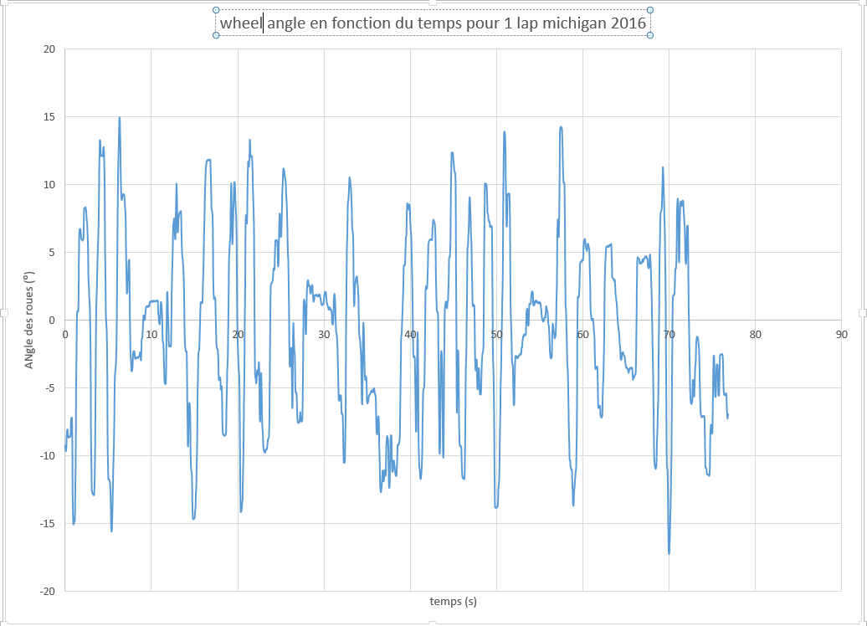

Compliance analysis based on Steve Fox cockpit efforts (100N*m * 1.35FS)

|  |  |  |  |  |  |  |  |  |  |  |  |  |
| --- | --- | --- | --- | --- | --- | --- | --- | --- | --- | --- | --- | --- |
| **CONSTRAINT+DEFORMATION ANALYSIS FOR STEERING TUBES** | | | | | | | | | | | | |
|  |  |  |  |  |  |  |  |  |  |  |  |  |
|  |  |  |  |  |  |  | MATERIAL PROPERTIES | | | | | |
|  |  |  |  |  |  |  |  |  |  |  |  |  |
| NORMAL MAXIMAL INPUT TORQUE | | | | (Nm) | 61 |  | MATERIAL | | | | (-) | Steel 4130 chromoly |
| DESIGN TORQUE | | | | (Nm) | 135 |  | YIELD STRENGTH | | | | (Mpa) | 435 |
|  |  |  |  |  |  |  | G | | | | (Mpa) | 80000 |
| EXTERNAL DIAMETER | | | | (mm) | 19.05 |  | DENSITY | | | | (g/cm3) | 7.85 |
| INTERNAL DIAMETER | | | | (mm) | 17.339 |  |  |  |  |  |  |  |
| LENGTH | | | | (mm) | 192.66 |  |  |  |  |  |  |  |
| J | | | | (mm4) | **4056** |  |  |  |  |  |  |  |
|  |  |  |  |  |  |  |  |  |  |  |  |  |
| **IMPORTANT RESULTS** | | | | | | | | | | | | |
|  |  |  |  |  |  |  |  |  |  |  |  |  |
| SHEAR CONSTRAINT | | | | (Mpa) | **634.1** |  | WEIGHT | | | | (g) | **73.96** |
| ANGULAR DEFORMATION | | | | (˚) | **0.08** |  |  |  |  |  |  |  |

SHIFTER SYSTEM

COMPONENTS

Bottle: HPA, 4500 psi , 68cc, carbon

Actuation: Buttons on steering wheel

Valve:  5/3, high reliability, SCORPION

Piston : Festo 25mm

Engine transmission lever: aluminum casted

ECU : ignition cut feature for up shifts

DESIGN OBJECTIVE

* Constant shifts
* Enough gas in bottle for endurance
* Keep driver focused

VALIDATION

* The bottle allows 2040 shifts at a 150 psi pressure
* The number of shifts is roughly 1056 according to data of Michigan 2016 endurance (Worst case 12 braking X Accel and Decel X 2 gear at max = 1056)
* Driver keeps his hands always on wheel

Force needed to shift is 100N (looked with a fish weight) and to be sure to shift we had a FS of 3.5

PEDAL BOX

Design objectives

* Reduce mass
* Make something cost efficient
* Adjustability
* More sensitive
* Linear feel

METHOD

We changed the layout of the pedals vs last year:

* The pedals are in bending but this allowed us to reduce chassis length and save weight afterward, so it is a good compromise
* Brake pedal is now bulkier but with all the modifications made to chassis including pedal box we saved 21.5 lbs to the chassis, with only a 0.132 lbs added to the pedal vs last year.
* Inverted layout made all components go underneath the floor and reduce chassis length
* Pedal box area is cleaner
* Cup are easily changeable to driver’s need (Ergo wise)
* Travel is adjustable on throttle pedal
* Sensitivity is adjustable on throttle pedal ( linear to be in sync with engine map)
* Same machining setup reducing cost
* Bearing setup is lighter with needle + thrust bearing

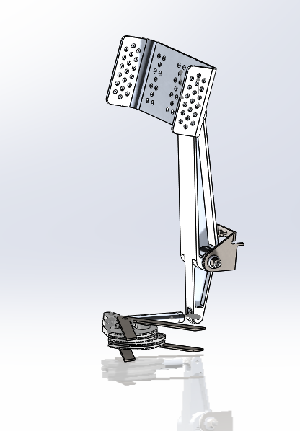

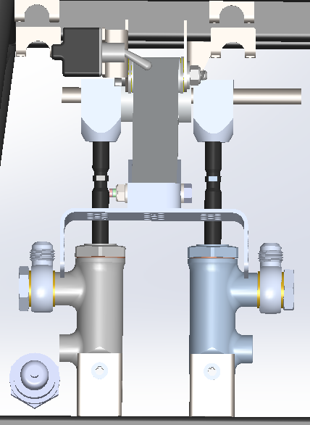

DRIVER’S POSITION / ERGONOMICS / SAFETY

SPECIFICATIONS

DRIVER’S POSITION / ERGONOMICS:

* Hands always on wheel
* Comfortable wheel
* Seat comfortable and able to sleep in the car
* Blind fold test easy to achieve
* Everything is easy to see on the dash and is well identified
* As said earlier pedal cups are interchangeable to accommodate drivers

SAFETY:

* Tubes higher than side impact
* Engine mounts can take up to 57 g before failure, a lot higher than the recommended 20 g

Design

Dimensions of the car were based on the fastest driver, and other drivers fit in the car with custom seat inserts for each.

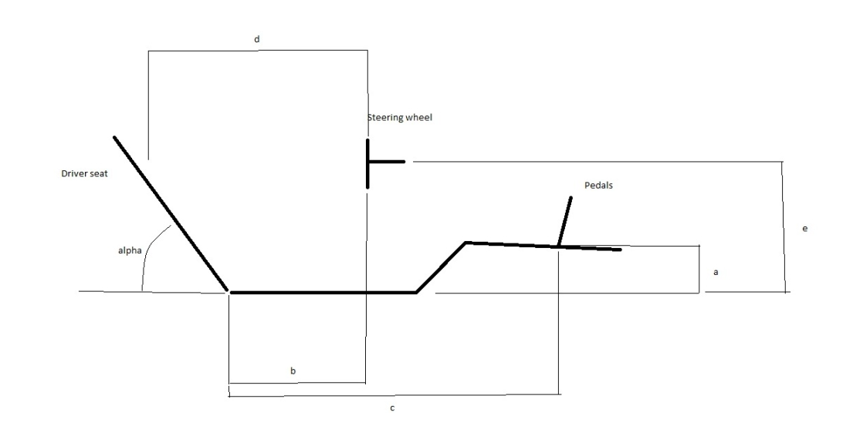

|  |  |  |
| --- | --- | --- |
| distance | measures | unit |
| a | 88.9 | mm |
| b | 319.31 | mm |
| c | 985.98 | mm |
| d | 604.38 | mm |
| e | 400.74 | mm |
| α | 52 | ⁰ |

Final measures of the car

With this setup the car accommodates the 5th female percentile and the 95th male percentile.

Angle: The angle of the seat is a compromise between visibility and CG height, the fact that the driver is more comfortable may allow him to do better lap time.

Comparison to F1 cars:

